**Daily Scrum or Standup Meeting**

Team name: Group 8_________________________

Scrum Master: Cole_______________________

Date: 3-12-2021_______________________________

|  |  |  |  |
| --- | --- | --- | --- |
| **Team Member** | **What did you do since the last scrum?** | **What do you plan to do before the next scrum?** | **What obstacles do you have?** |
| Cole | Got too deep into React and drowned | Back up, and try again from the tutorial | I still don’t remember JS very well |
| Jeremy | Continued working on Django APIs, significant progress being made in DB work | Keep working on the database | None |
| Austin | Got login forms and React routes working (without APIs, at least for now) | Keep working on React customer stuff | Time |
| Logan | Kept working on React tutorial | Finish React tutorial | Time |
|  |  |  |  |

# Burndown

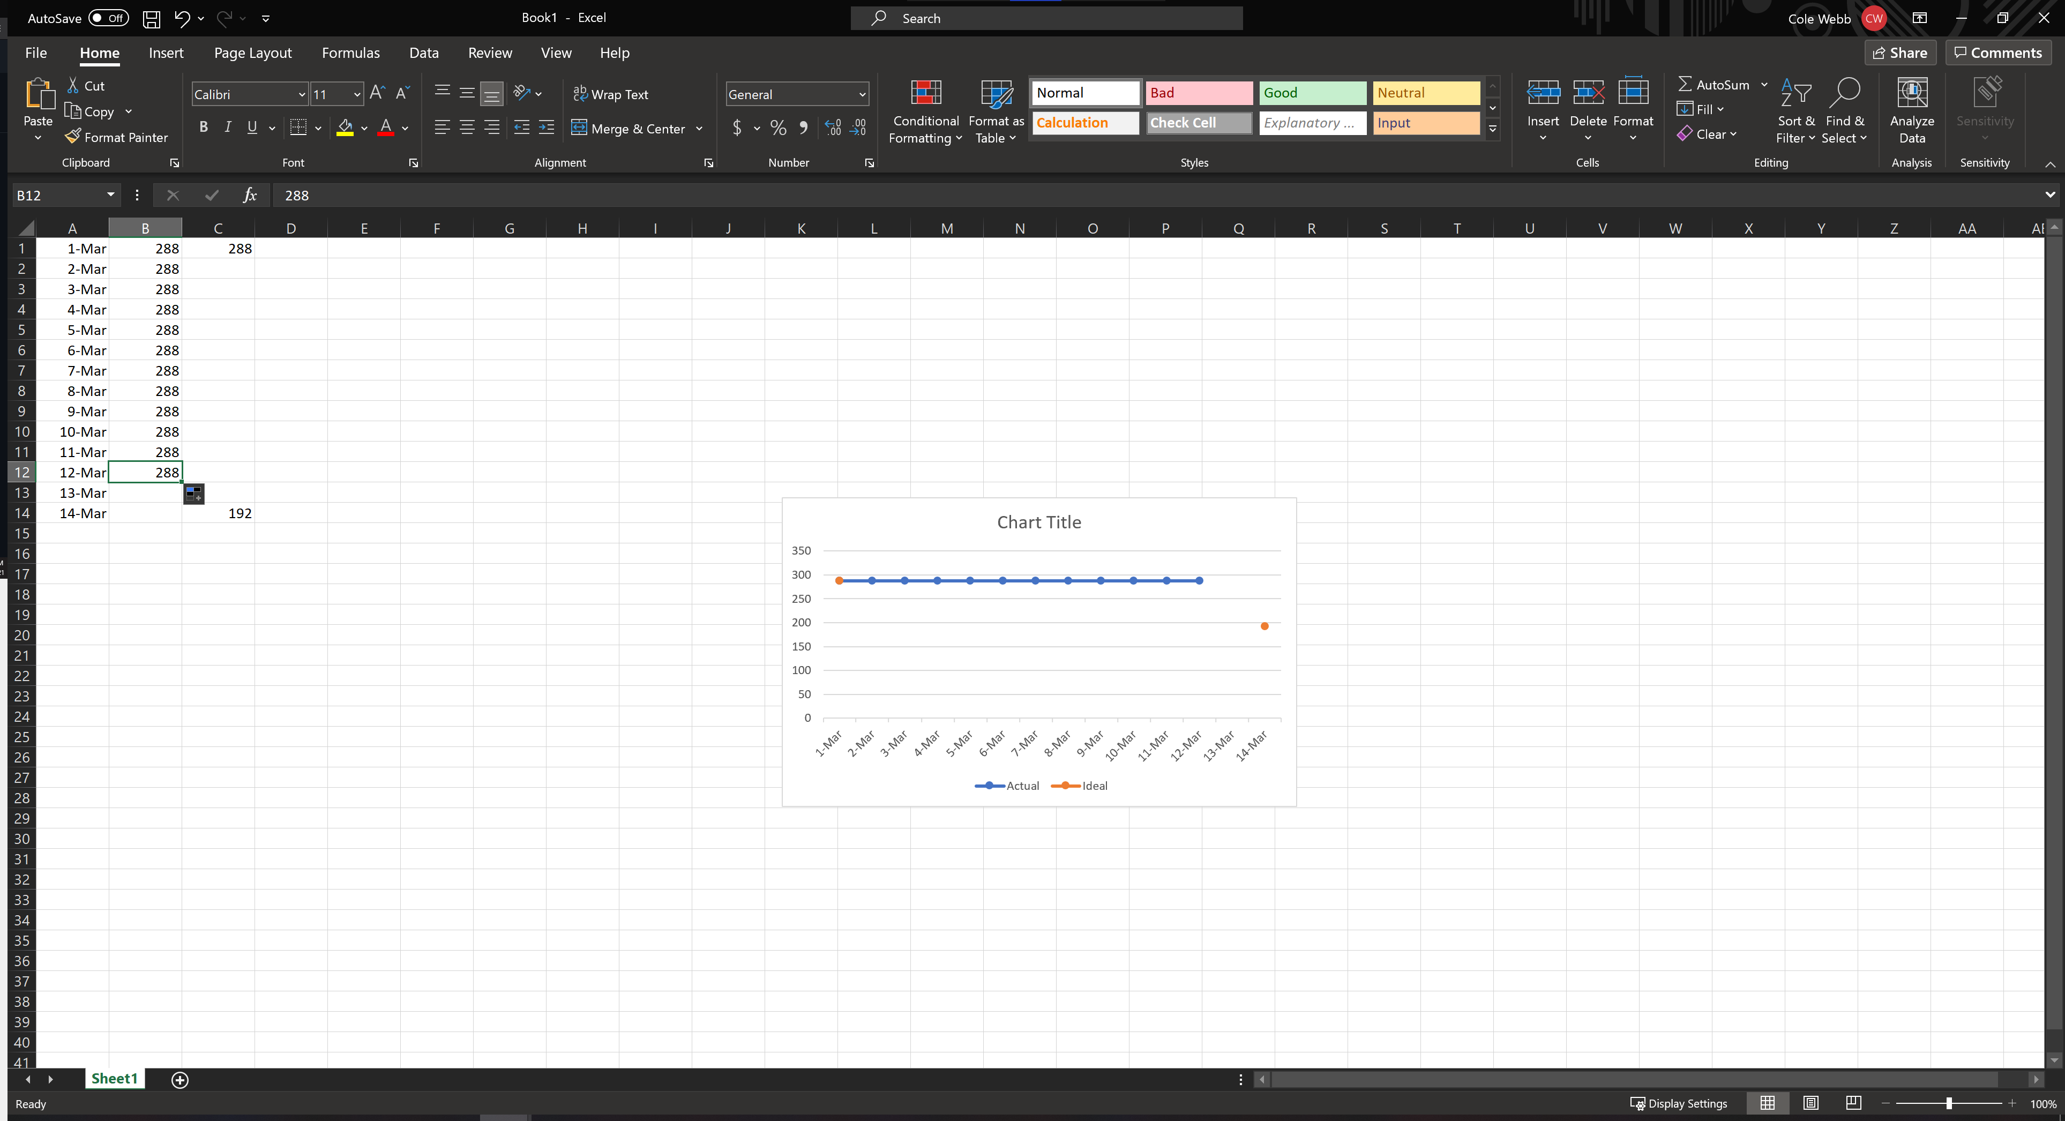

# Screenshot of you project board

